**Head office: M.C. Block No. 2, Second Floor, Gill Road, Ludhiana – 141003**

**Office Complex: E-648/A, Focal Point, Phase - V, Ludhiana – 141010**

**Email:** [**cicu@cicuindia.org**](mailto:cicu@cicuindia.org)**, website: cicuindia.org**

**50**

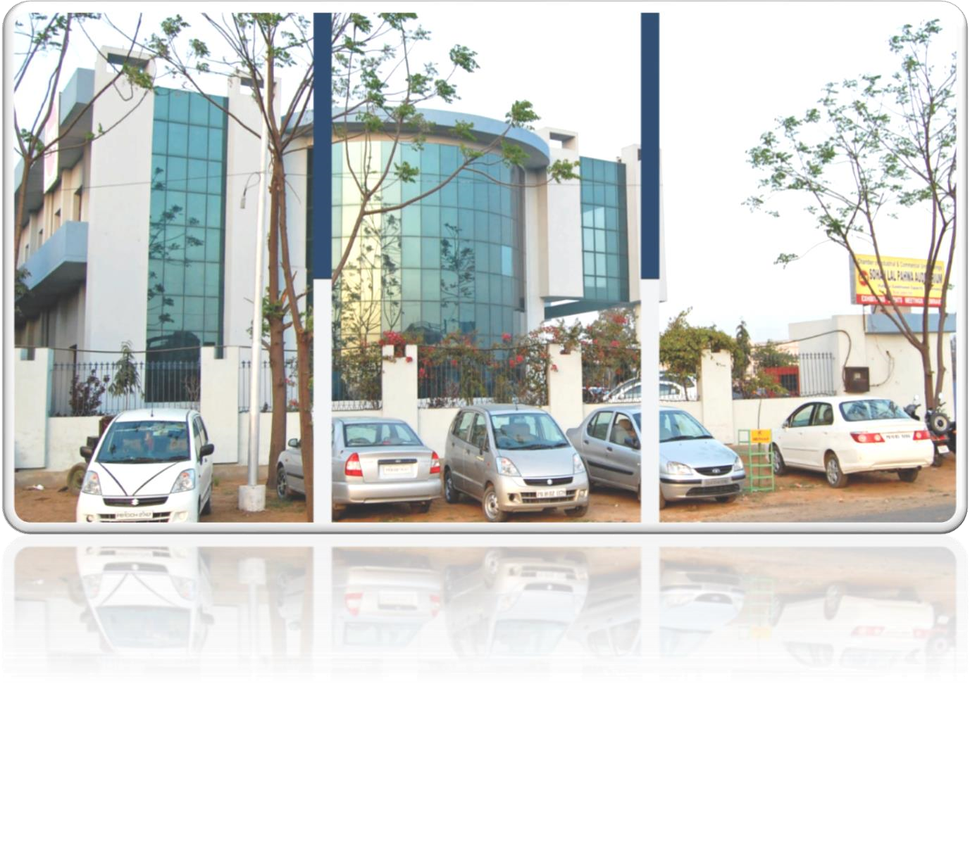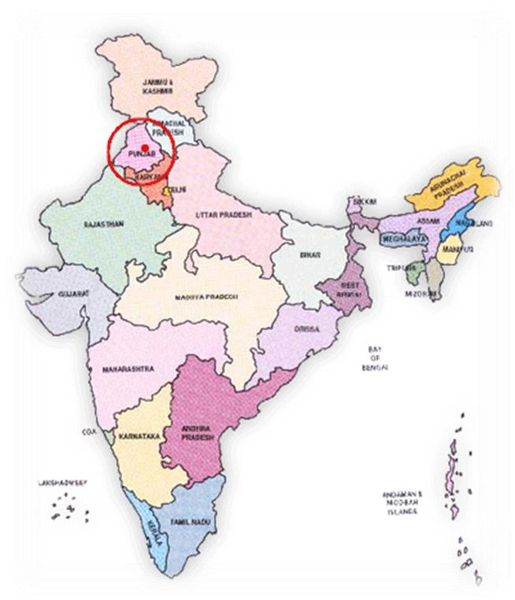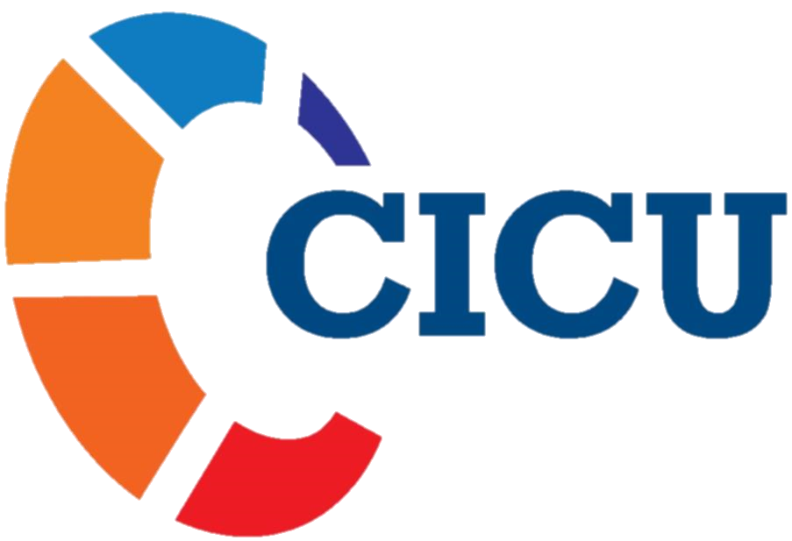

**Years of Service to**

**Trade & Industry**

**ABOUT CHAMBER OF INDUSTRIAL & COMMERCIAL UNDERTAKINGS (CICU)**

Chamber of Industrial & Commercial Undertakings (CICU) is a nodal industrial & commercial organization which represents Industrial & Trade Sectors of the State of Punjab since 1969 & is recognized by the Govt. of India, Ministry of Commerce & Industry for dealing with the development & regulation of Imports & Exports. CICU-Ludhiana is enjoying world level recognition being members of the world Chamber’s congress Marseille, France. Presently, we have direct membership of more than 1200 and indirect membership of more than 13,000 of 36 different Industrial associations are the strength of this apex organization. Our membership comprising different industrial sectors i.e. Auto, Tractor & Farm Parts, Machine Tools, Woolen Garments, Yarn & Textiles, Cycle & Cycle Parts, Machine Tools, Engineering Goods, Sewing Machines , Hand Tools, Motor Parts, Sport Goods, Leather Goods, Handicrafts, Fasteners Industry, Cutting Tools, Hosiery &, Food Processing Industry, Agriculture Machinery and many more.

This is the only organization in the State of Punjab which has got Country's Level First Award as BMO doing services for the development of MSME sector. It is an ISO 9001:2015 Certified Non-Profit making organization. It is accredited with Silver standard by Quality Council of India and National Accreditation Board for Education & Training (NABET).

**NATIONAL & INTERNATIONAL ACTIVITIES OF CICU**

1. Represents interests of business, industry and Trade with State and Centre Governments.
2. Conducts useful Seminars, Workshops, discussions training programs on important conducive to Growth and Development of industrial factory (List attached).
3. Invite top mentors, industrialists, other government dignitaries for expert advice on sources and availability of credit, capital investment, financial appraisal of projects and cluster development.
4. Signing of various MoUs with the leading companies which help our members to learn the best practices of industry and trade for their benefits.
5. Leads overseas business delegations and provide latest business opportunities thru technology transfer / up gradation and cross learning of our members.
6. Providing skill training to the educated unemployed and underemployed youth for making them employable for industry & trade sector of Punjab.
7. CICU has signed MoUs with many education institute like GNEC, GNKC for Woman, SCD Govt. Collage for boys, BBSBC, SDPC for Industry - Institute Interactions to bridge a gap between academia and industry so that the students acquire the knowledge as per need of the industry and trade.
8. Organizing job fairs for providing skilled manpower to industry & trade as well as employment to the youth passing out from engineering & management institutes.
9. Advocacy on Industry related issues at State & Central Govt. level.
10. Organizing B2B Exhibitions for promotion of import & export & Trade Fairs.
11. Interaction with Delegations from foreign countries for Import and Export Promotion.
12. Taking Delegations to Foreign Countries for latest Technology / knowhow for its up gradation & promotion of business.
13. Organizing Industrial sports activities like T20 Corporate Cricket Tournament and Chess Competition etc.
14. Issuing Certificate of origin for Export of Indian Manufacture Goods.
15. We are a training partner of Government of India and Government of Punjab to impart skill trainings under PMKVY and PSDM for providing skill trainings to the youth for suitable jobs in the industry and trade.
16. CICU has established a NABL approved Calibration Centre (CICU-SSC Technical Centre) at our Gill Road office, for certification and testing of measuring instruments.
17. CICU has formed a special group called Young Business Leaders Forum “YBLF” Comprising of around 175 young members in the age group of 18 to 35 years, for grooming them in all industrial activities as per their special requirements / needs.
18. CICU organizes many programs on Webinar or Motivational and up grading subjects to utilize the time of its members during Lockdown and Curfew period for their benefits.
19. Many important Zoom meetings were organizes by CICU to discuss issue being face by exporters due to Covid-19 pandemic situation.
20. CICU organize 3 days Certified Training program on HEAT-TREATMENT PROCESSES, MICROSTRUCTURE & PROPERTIES OF STEELS.

**CICU OFFER VALUE ADDED SERVICES FOR MEMBERS:-**

1. Concession on Training/Seminar Charges.
2. 15-20% Discount on selected Hotels/Restaurants (on Room booking & Food).
3. Discount on Bulk Purchase of Diesel at selected Petrol Pumps.
4. Discount on Insurance (General/Life/Health).
5. Exhibition Participation as Priority Members.
6. Discounted Price on Advertisement Charges in CICU Directory/Newsletters.
7. Discount in Calibration Services at CICU-SSC Calibration Centre, Gill Road, Ludhiana.
8. Discount on CNC Tooling.
9. IT related Services.
10. Discounts on Electricals & Electronics appliances.
11. Discount on selected hospital network

**OTHER BENEFITS BEING OFFERED BY CICU**

1. Advise on IPR Related Services.
2. Advise on Business Excellence Services.
3. Advise on Legal Services.
4. Various Advise on PSPCL, Ground Water Use, PSIEC, DIC, MSME and other Govt. departments.
5. Awareness of Subsidy of the State & Centre Govt. for MSMEs.
6. Advise on GST Return.

**CICU SUB COMMITTEES TO RESOLVE THE ISSUES OF INDUSTRY**

1. CICU Export Promotion Committee
2. CICU Green Manufacturing Committee.
3. CICU Legal & Taxation Committee.
4. CICU Finance Committee.
5. CICU has formed Food Cluster.

**ANNEXTURE- I**

|  |  |  |
| --- | --- | --- |
| **LIST OF SEMINARS, WORKSHOPS AND OTHER ACTIVITIES** | | |
| **S .NO** | **NAME** | **VENUE** |
|  | Program on Udaymimtra by SIDBI | CICU |
|  | 9th Kaizen Competition | CICU |
|  | Program on Goods & Service Tax with a with special focus on e-way bill procedures | CICU |
|  | Program on BSE-SME at Park Plaza | CICU |
|  | Two Days Training Program On Manufacturing Excellence Thru SPC. | CICU |
|  | Live Session of Union Budget 2018-19 | Park Plaza |
|  | Executive Committee First meeting to Introduce the new nominated Members | CICU |
|  | One Day Training Program on Metallurgy Advancements | CICU |
|  | Interaction with S. Jaskiran Singh, IAS, Commissioner, Municipal Corporation, Ludhiana | CICU |
|  | CICU is organized 5 Days Certified Training Program on Enterprise Excellence (First Program) | CICU |
|  | Meeting regarding Up gradation of Central Tool Room (CTR) | CTR |
|  | Inauguration Ceremony of Ludhiana Branch of Lakshmi Vilas Bank by S. Upkar Singh Ahuja-President, CICU at Dugri Road, Ludhiana | Branch Address |
|  | CICU in association with Ministry of Railways-Research Designs & Standards Organization organized a Seminar on Vendor Development for manufacturing units of Punjab State | CICU |
|  | CICU in association with Cad craft System Pvt. Ltd. Organized a seminar on Design innovation & Faster Manufacturing | CICU |
|  | Final Match of CICU Corporate T-20 Cricket Tournament between Highway V/s Deepak Fasteners | Govt. College |
|  | Interactive discussion with Malaysian Delegation for new Business Opportunity.  (Chief Guest DPS Kharbanda, IAS, Director of Industry & Commerce, Punjab | CICU |
|  | 2nd CICU is organized 5 Days Certified Training Program on Enterprise Excellence | CICU |
|  | CICU in association with PHD Chamber of Commerce organized interactive session on Procedures and Issues in Refund & E-Way Bill under GST. | CICU |
|  | CICU Delegation honored and welcomed Sh. Balkar Singh, Mayor, Municipal Corporation, Ludhiana. |  |
|  | CICU Holds ‘Interactive Meeting’ With Sh. Sandeep Sharma, PPS, ADCP, Ludhiana & Focal Point Police Department | CICU |
|  | CICU Food Processing Cluster holds an Interactive Meeting with Sh. D.P.S. Kharbanda, IAS, Director of Industries & Commerce, Govt. of Punjab & a Specialist Team of Food Industries Business Incubation Centre, P.A.U at CICU Complex, Focal Point, Ludhiana. | CICU |
|  | 4th Panel discussion on World Class Manufacturing | Park Plaza |
|  | Welcomed and Honored New Commissioner of Police, Sh. Sukhchain Singh Gill, IPS. | C.P office |
|  | 3rd day of 5 Days Certified Training Program on Enterprise Excellence | CICU |
|  | Interaction With Sh. K.S Pannu, IAS, Chairman, PPCB | CICU |
|  | Discussion on “WINNING IN TURBULENT TIMES” by Mr. Mohit Goel, CEO-Omaxe Ltd. | Park Plaza |
|  | CICU Delegation met with Sh. Sunder Shyam Arora, Hon’ble Cabinet Minister  Industries and Commerce, Govt. of Punjab. | Chd |
|  | 3rd Day of 5 Days Program on Enterprises Excellence | CICU |
|  | Chamber of Industrial & Commercial Undertakings organized a meeting with Additional Director of Technical Education & Industrial Training Punjab | CICU |
|  | JOB FAIR  Chief Guest: Sh. Charanjit Singh Channi, Minister of Technical Education & Industrial Training Punjab | CICU |
|  | Program on Stress Management at Park Plaza  With Dr. Sukhchain Singh Gill, IPS, Commissioner of Police | Park Plaza |
|  | First Export Committee Meeting | CICU |
|  | 2nd Executive Committee | CICU |
|  | A Delegation of CICU Welcomes and Honored  Sh. Sanjeev Kumar, Chief Engg. PSPCL, Ludhiana at his office. |  |
|  | S. Upkar Singh Ahuja, President, CICU Awarded for Environment Excellence  For the year-2018. | CICU |
|  | One day Training Program on Low Cost Automation | CICU |
|  | Awareness Program on Industrial Labour Laws & ESI Schemes  Hon’ble Tejinder Singh Dhaliwal, IAS, Labour Commissioner, Govt. of Punjab by Chamber of Industrial & Commercial Undertakings, Ludhiana on June 20, 2018 | CICU |
|  | Key Challenges of SMEs by Business Standard News paper | CICU |
|  | Business Communication & Negotiation Skills | CICU |
|  | Mass Tree Plantation Drive | CICU |
|  | Awareness Program on Labour Laws, ESI and PF Schemes | CICU |
|  | Meeting with Sh. Paramjit Singh, Chief Engg. PSPCL | CICU |
|  | Chess Competition | CICU |
|  | Poke Yoke | CICU |
|  | One day Workshop on Quality Improvement Through “Poka Yoke : Human Mistake Proofing” | CICU |
|  | How to Be a smart SME | Celebration Plaza |
|  | CICU Delegation met with Sh. Pardeep Gupta, Chief Engg. Punjab Pollution Control Board regarding various issues of PPCB. | PPCB Office |
|  | Meeting with D.P.S Kharbanda, IAS, Director of Industries & Commerce, Govt. of Punjab, Sh. J.K Jain, PCS, Additional Commissioner cum Zonal Commissioner Zone-B, MC, Ludhiana, PSIEC Officials and others Govt. Officials.  Regarding infrastructure of Focal Point Area | CICU |
|  | Meeting with Captain Amarinder Singh | Park Plaza |
|  | Technical Education & Industrial Training, Govt. of Punjab organized “Enhancement of Skill Efficacy in Vocational Training" | Guru Teg Bahadur Hall Punjabi University, Patiala. |
|  | Meeting with Panasonic Team  Mr. Shigeki Yonemori, Div. Managing Director, | CICU |
|  | Seminar on “Good HR Practices for SMEs” | CICU |
|  | Modern Ways of SME Finance | Park Plaza |
|  | A high level delegation visited Singapore, to attend Invest North – Leveraging Business & Investment Opportunities. | Singapore |
|  | CICU in association with DIC organized Awareness & Free Registration Camp on ZED Certification Scheme | CICU |
|  | A Seminar on 'SIGNIFICANCE OF INTELLECTUAL PROPERTY PROTECTION – A LEGAL AND BUSINESS PERSPECTIVE | CICU |
|  | CICU Delegation Visit to Automechanika-2018 at Frankfurt, Germany.  (11.09.2018 to 17.09.2018) | Frankfurt, Germany |
|  | CICU Planned for Group Participation in India Show-2018 at Ashgabat in Turkmenistan.  (Meeting with ITPO). | CICU |
|  | One Day Workshop on Daily Work Management | CICU |
|  | CICU STRONGLY DEMANDED SIMILAR FUND FOR MSME LIKE STARTUPS TO OBTAIN FINANCE AT LOW COST | CICU |
|  | CICU Delegation met with Sh. O.P Soni Hon’ble Environment Minister, Govt. of Punjab. | CICU |
|  | CICU Delegation Meets Ms. Kanwalpreet Kaur Brar, IAS, Commissioner, Municipal Corporation, Ludhiana. | CICU |
|  | Interaction with Sh. Prof. Satwinder Singh Marwaha, Chairman, Punjab Pollution Control Board | CICU |
|  | CICU to Submit Standard Operating Procedure for Rain Water Harvesting to PPCB Shortly. | CICU |
|  | CICU opposes hike in tariff from PSPCL for Industrial Units. | CICU |
|  | CICU Inaugural Function of 5th T-20 Cricket Tournament - 2018 and First and Second League Matches | CICU |
|  | 3rd Executive Committee Meeting | CICU |
|  | One Day Workshop on Improving Weld Quality and Productivity | CICU |
|  | Motivational Session on “My Two Cents of Wisdom” by Mr. Ujjwal Munjal, M.D., Rockman Industries Ltd & Founder Director - HERO Electronix Pvt. Ltd. | Park Plaza |
|  | CICU Delegation meets with Sh. Suresh Kumar, IAS, Chief Principal Secretary to Chief Minister of Punjab | CICU |
|  | CICU Signs MoU with GGNIMT | GGNIMT |
|  | Interaction with Mr. Sunil Kumar Sawhney, IRS (Chief Commissioner of Customs (Preventive)-Delhi Zone on Customs related issues & queries.  And Mr. A.S Ranga, IRS, Costumes Ludhiana | CICU |
|  | CICU member Companies to Recruit 1000 ITI holder during Job Fair on 19th, 20th, 21st, 22nd November. | ITI |
|  | CICU Organized Workshop on Effective Strategies for Digital Marketing | CICU |
|  | CICU Organised MACHMA Expo | GLADA Ground Ludhiana |
|  | Program on Industry 4.0 | Park Plaza |
|  | CICU & UCPMA Delegation meets PPCB Chairman prof. Satwinder Singh Marwaha | Patiala. |
|  | Interaction with Dr. Sukhchain Singh Gill, IPS, Commissioner of Police, Ludhiana | CICU |
|  | CICU Empaneled as Skill Development Partner under Punjab Skill Development Mission. | CICU |
|  | CICU ENVIRONMENT IMPROVEMENT (GREEN MANUFACTURING) COMMITTEE FORMED.  1st Meeting of the committee | CICU |
|  | CICU to take action for Fire Safety of Industrial Units by holding Training Workshop | CICU |
|  | Executive Committee Meeting | CICU |
|  | National 10th Kaizen Competition a Booming Program Organized by CICU Drawn Overwhelming Response | CICU |
|  | S. Upkar Singh Ahuja, President, CICU Awarded for Outstanding Contribution in Leading the Society towards betterment.  For the year-2019. | CICU |
|  | CICU ACTIVELY PARTICIPATES IN BUDHA DARIYA CLEANING | Tajpur road |
|  | Training Program on Operational Excellence Through M.I.S. | CICU |
|  | Budget Session-2019-20 | Shiraj Hotel |
|  | Interaction with Central Ground Water Authority Senior Officials regarding Ground Water issues | CICU |
|  | Training Program on Cost Effective Management | CICU |
|  | CICU TOP CEOs MEET  WITH THE GROWTH VISION 2025 | Park Plaza |
|  | CICU DELEGATION VISITS RCF UNDER VENDOR DEVELOPMENT PROGRAM | RCF Kapurthala |
|  | CICU in association with PWC & World Bank, organized Certification Program cum Capacity Building & awareness workshop on resource efficiency & Cleaner Production. | CICU |
|  | A meeting regarding formation of Special Purpose Vehicle (SPV) for maintenance of Infrastructure of the Focal Point Area with DIC, PSIEC senior officials. | CICU |
|  | CICU in association with SME Venture and Schneider Electric organized Seminar on "Leveraging Technology for Business Growth" held on 20-Feb.-19 | Radisson Blu, Ludhiana |
|  | CICU Delegation visited TIMTOS-2019 International Exhibition at Taipei, Taiwan | Taiwan |
|  | CICU Organized One Day Training Program on “Good Strategies for Product Pricing” | CICU |
|  | Awareness Program on How to Apply NOC for Ground Water by Mr. Arun Bhatt | CICU |
|  | One Day Workshop on How To Design MIS For CEOs And Top Management | CICU |
|  | Executive Committee Meeting | CICU |
|  | 3rd Export Promotion Committee Meeting | CICU |
|  | One Day Training Program on Be a Magnificent Manager. | CICU |
|  | Technology Exhibition-cum-Workshop by PWC, Bureau of Energy Efficiency | CICU |
|  | CICU YBLF Organized Motivational Session on “Change begin with me”  conducted by Mr. Ravi Kapoor, Certified Life Coach, Nablings Services Pvt. Ltd, New Delhi. | CICU |
|  | CICU Organized SME Conclave Focus on Lean Manufacturing & IT | Park Plaza |
|  | Vendor Development Program by Rail Coach Factory (Kapurthala) and Northern Railway | CICU |
|  | Press releases  CICU condemn Hike in Electricity Charges. | CICU |
|  | One day Training Program & Competition on  “Poka Yoke : Human Mistake Proofing” How to improve Quality & Productivity by using Japanese Concept | CICU |
|  | YBLF Visit to Marshall Machines Ltd. | Marshall Machines Ltd. |
|  | Executive Committee Meeting | CICU |
|  | Export Committee Meeting | CICU |
|  | CICU Skill Development Centre Celebrated the World Environment Day Function. | CICU |
|  | CICU Skill Development Centre Organized Session on Stress Management. | CICU |
|  | CICU Executive Committee held to discuss Industrial issues. | CICU |
|  | Delegation of CICU met with Sh. Pardeep Aggarwal, IAS, Deputy Commissioner Ludhiana | DC OFFICE |
|  | CICU to take action for Fire Safety of Industrial Units by holding Training Workshop | CICU |
|  | CICU Delegation visited ITMA-2019 at Barcelona, Spain | CICU |
|  | CICU in Association with District Bureau of Employment & Enterprises Organized Job Fair/Rojgar Mela. | CICU |
|  | CICU Organized One Day Training Program on Manufacturing Excellence through Metallurgy Advancements. | CICU |
|  | Impact of the Union Budget-2019-20 | Shiraj Hotel |
|  | One Day Workshop on Marketing Essentials in the Digital Age on 06.07.2019 at CICU Complex | CICU |
|  | Interaction With Sh. Som Parkash, Hon'ble Union Minister of State, Commerce & Industry (GOI) on 14.07.2019. | Park Plaza |
|  | CICU Work Recognized at National Level and Won the Prize for Outstanding Association Awards 2018-19 in 2nd Annual Award Function at MICE Conference and Expo Awards | Delhi |
|  | A high level Delegation from Taiwan External Trade Development Council (TAITRA) visited CICU | CICU |
|  | CHAMBER OF INDUSTRIAL & COMMERCIAL UNDERTAKINGS SIGNS MOU WITH GNE COLLEGE | CICU |
|  | Chess Competition | CICU |
|  | Interaction meeting with Smt. Ranjana Jha, IRS, Chief Commissioner of Customs (Preventive), New Delhi and Sh. A.S Ranga, IRS, Commissioner, Customs Commisisonerate, Ldh | CICU |
|  | CICU Organizing Mass Planation Drive and Environment Excellence Award | CICU |
|  | Interaction with Sh. Gurpreet Singh Gogi, Chairman, PSIEC. | CICU |
|  | NPC Six Waste Management Rules, 2016” being conducted | RaddisonBlue |
|  | WORKSHOP ON TECHNICAL NEEDS OF MSMEs | CICU |
|  | Optical Emission Spectrometers (OES) for metal testing with Metal Power Analytical Private Limited. | CICU |
|  | Press Note: SPV under Pressure |  |
|  | A High Level French Delegation visited CICU to do with Punjab Industry | CICU |
|  | Delegation met S. Manpreet Singh Badal , Finance Minister Punjab |  |
|  | CICU Organized Medical Health Camp and Workshop on Basic Industrial Safety, First Aid, OHS (Operational Health & Safety). | CICU |
|  | Workshop on Striving for Excellence | CICU |
|  | CICU organized Program on “HOW TO BECOME A SMART SME-2’’ at Shimlapuri, Celebration Plaza. | Celebration Plaza |
|  | CICU & IIMM JOINTLY ORGANISED JOB FAIR AT D.D. JAIN COLLEGE | D.D. JAIN COLLEGE |
|  | CICU Delegation visited EMO Hanover, Germany |  |
|  | CICU & DIC organized Mass Tree Plantation at District Industry Centre |  |
|  | Business Unplugged” with The Times of India group at Hotel Park Plaza, Ludhiana. | Park Plaza |
|  | Punjab Research & Innovation Consultative meeting with Sh. R.K. Verma, IAS, Principal Secretary to Govt. of Punjab, Department of Science, Technology & Environment, Govt. of Punjab. | Chd. |
|  | CICU Organizes 6th CICU T-20 Corporate Cricket Tournament- 2019 for Cricket Lovers | Ludhiana |
|  | CICU President & CMD New Swan Group S. Upkar Singh Ahuja has been awarded for service to Punjab Industry. |  |
|  | Seminar on Global Selling by Amazon |  |
|  | Awareness Program on ATA Carnet in association with FICCI | Ludhiana |
|  | Cricket Tournament | Ludhiana |
|  | Interaction with Senior Automation Industry Experts | Ludhiana |
|  | With the Efforts of CICU, PSIEC resolved the issues of Plot holders of Focal Point regarding of allotment, mortgage, transfer, change in constitution, Reg. of Lease-Deed on Grievance Redressal Camp | CICU |
|  | Workshop on Improving Weld Quality & Productivity | CICU |
|  | Simulation Driven Smart Manufacturing by German Expert from Ryanus Technologies | CICU |
|  | T-20 Match | CICU |
|  | Workshop on Building World-class Organization | CICU |
|  | 3 days Certified Training program on HEAT-TREATMENT PROCESSES, MICROSTRUCTURE & PROPERTIES OF STEELS. | Institute of Auto Part and Hand Tools, |
|  | CICU Promoting Skill Trainings for Employment of Educated Youth | At Gill Road |
|  | 7th MACHMA EXPO-2019 | GLADA Ground |
|  | Workshop On Daily Work Management | CICU |
|  | Interaction with Police Commissioner | CICU |
|  | One Day Workshop on Optimum Utilization of CNC Machine | CICU |
|  | workshop on Lean Manufacturing | CICU |
|  | Workshop on Humanography | CICU |
|  | 11th Edition of Kaizen Competition | CICU |
|  | Workshop on Basic Concepts in Industrial & Fire Safety Management | CICU |
|  | Live Budget Session FY 2020-21 | CICU |
|  | Workshop on Digitization in MSMEs by SIEMENS | CICU |
|  | Discussion on World Class Manufacturing | At Jalandhar |
|  | Workshop on “Productivity improvement through Lean Manufacturing and Smart Manufacturing(Industry 4.0)” | CICU |
|  | YBLF Visit to Sawraj Mahindra at Mohali | Mohali |
|  | Vendor Development visit at RCF | RCF |
|  | Inception workshop for forging sector by PWC | CICU |
|  | CICU organized a Webinar on “Opportunities out of China post COVID Scenario” | CICU |
|  | Webinar on Motivational Talk on Charge Yourself for New Inning Post COVID | CICU |
|  | A Zoom meeting was organized by CICU to discuss issues being faced by the Exporters due to COVID-19. | CICU |
|  | CICU affiliated 33 Industrial Associations shared their issues & Suggestions due to COVID-19. | CICU |
|  | Webinar on Role of HR | CICU |
|  | Webinar Workshop on Effective Use of Advanced MS -Excel. | CICU |
|  | CICU Utilizing time for motivation and Upgrading the Members through Webinar on Daily Work Management | CICU |